Lecture No.7 PARASITOLOG DR.Raad H.H.
Order Rhabditida
Rhabditida is an order of free-living, zooparasitic and phytoparasitic microbivorous nematodes (roundworms).
Order include 8 superfamilies.
- Oral aperture with 2, 3 or 6 lips. Stoma has five departments .
General character :
- smallest size worms.
- Mouth ,With Small buccal cavity.
- Esophagus ,Rhabtidi form.
- Male reproductive system ,No cpoulatory bursa ;but have posterior end with 2 small equal spicules.
- Egg shape, eggs of worms with L ₁.
- Life cycle ,Direct.
- Infective stage , L₃Penetrate skin.

Family Rhabditidae
Genus "Strongyloides"
It is a large group containing small free living form parasites ; The genus Strongyloides which very representative ,includes large No. of species living in birds , amphibians , reptiles & mammals (horse, cattle , dog , cat ,primates, human).
The genus Strongyloides contains 53 species and S. stercoralis is the type species. S. stercoralis has been reported in other mammals, including cats and dogs. It has alsobeen reported from cats, which may harbor at least 3 other members of this genus (S. felis, S. planiceps and S. tubefasciens; from the goat Strongyloides papillosus.

- Thread worms causing a disease called Strongyloidiasis.
Strongyloides stercolaris
- Morphology :
Thread worms varies in size & shape depend on whether it is parasitic (heterogonic life cycle) or free living (homogenic life cycle).
- Whereas males grow to only about 0.9 mm in length, females can be anywhere from 2.0 to 2.5 mm
- S. stercoralis is an unusual parasitic nematode in several respects: it can multiply within the host, it has a free living life cycle
- in addition to its parasitic one, and only parthenogenic females are found in the host.
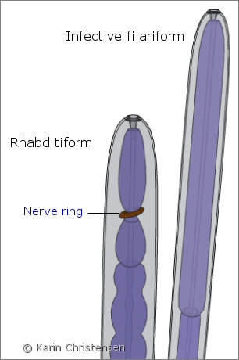
- Strongyloides stercoralis is a small nematode that infects the intestine of dogs and primates (including humans).

Life cycle:
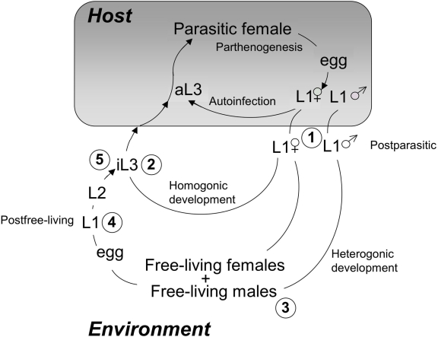

Figure 1: Life cycle of S. stercoralis
The diagram depicts the three possible developmental fates of hatchling first-stage larvae (L1 within the shaded box indicating the host). First, is the autoinfective cycle, unique to S. stercoralis, in which development from the L1 to the autoinfective L3 (aL3) occurs within the gut of the primary host. Autoinfection can lead to fulminant cycles of development and a highly pathogenic disseminated infection. All postparasitic male L1 develop to free-living adult males. Postparasitic female L1 passed in the feces may undergo development by either of two alternative pathways. The homogonic cycle involves direct development to the infective L3 (iL3), and heterogonic development involves development to the free-living female and, following mating, production of a generation of free-living progeny. All progeny of the free-living adults develop to the iL3. Larval stages between the post-parasitic L1 and the aL3, iL3 or free-living adult as well as between the iL3 or aL3 and the parasitic female are omitted for the sake of clarity. Encircled numbers refer to stages that may be recovered
Symptoms:
- Most infected dogs are asymptomatic and become occult in 8 to 12 weeks. Barren adult females may survive embedded in the intestinal mucosa for several months after the L1 are no longer found in the feces.
- These infections can be reactivated by immunosuppression attributable to either chemotherapy, concurrent disease, or perhaps pregnancy .
- Dogs that have self-cured are resistant to re-infection.
- Mature dogs seldom become severely infected and autoinfection is rare in these dogs.
- In young pups, autoinfective strongyloidiasis occurs spontaneously. Although these infections are usually mild and self-limiting, in some animals the worm burden may increase to clinically significant levels associated with watery or mucus diarrhea and with signs of bronchopneumonia due the migrating autoinfective third-stage larvae.
Pathology
- Intestinal pathology varies with intensity of the infection which in turn varies with the strain of the worm and the age of the dog.
- In asymptomatic infected dogs, the intestinal tissues may be grossly normal and worms and larvae exceedingly difficult to find by histological methods.
- In symptomatic cases, gross intestinal changes range from congestion of mucosal surface with an abnormal abundance of mucus in the lumen, to confluent ulceration that may penetrate to the muscular layer.
- In cases of severe infection, large numbers of parasites will be present in the intestinal wall .
- The full spectrum of parasite life history stages may be found in the gastrointestinal tract and filariform larvae in the lungs may be associated with pulmonary hemorrhage
- . The number of migrating larvae frequently does not correlate with the amount of pulmonary hemorrhage

Diagnosis:
- The presence of free rhabditiform larvae in the feces is diagnostic.
- Culture of stool for 24 hours will produce filariform larvae .
- First-stage larvae are passed in the feces, making concentration techniques using saturated salt solutions unreliable, as the larvae become so crenated as to be almost unrecognizable. However, fecal flotations done with zinc sulfate yield readily identifiable larvae provided that the preparation is examined promptly, before the larvae shrink. When zinc sulfate flotation solution is unavailable, a Baermann apparatus can then be used to obtain clean, intact larvae from feces for a definitive diagnosis. The first-stage larvae are easily recognized, their genital primordium being exceptionally prominent , making it easy to tell S. stercoralis L1 from Filaroides spp. L1 (lungworm nematodes )which may also be in the feces of dogs.
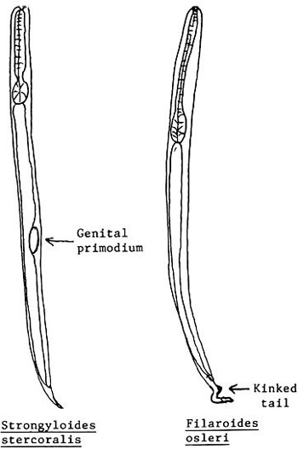

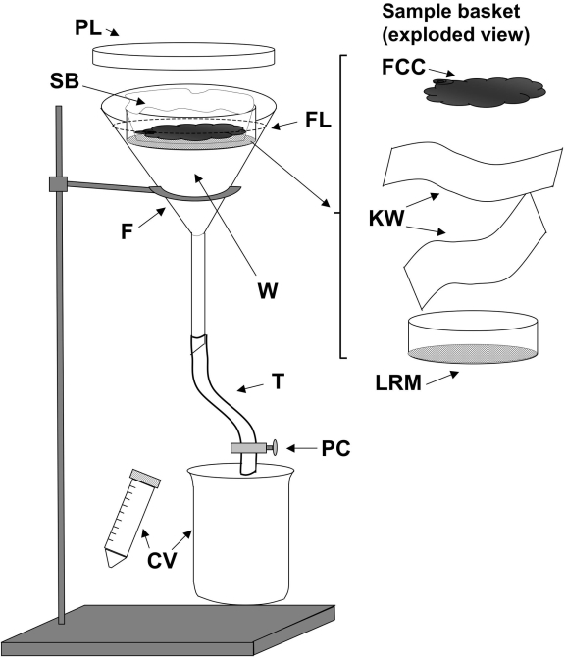

Figure 3. A Baermann apparatus as used to isolate Strongyloides stercoralis stages from coprocultures :
F, 150mm glass or plastic funnel; W, tap water at 43°C; FL (dashed line) fluid level in funnel; SB, Sample basket shown to right in exploded view (FCC, fecal charcoal culture contents; KW, two layers of Kimwipes or other laboratory tissue; LRM Lucite ring with nylon mesh affixed with cement; T, rubber or plastic tubing; PC, pinch clamp; CV, catch vessels, conical centrifuge tube, or beaker.
Epidemiology in Human :
- Thread worm infection, also known as "Cochin-China diarrhea", estimated at 50-100 million.
- It is an infection of the tropical and subtropical areas with poor sanitation.
- In the United States, it is prevalent in the South and among the Puerto Ricans.
- In Iraq ; Strongyloides reported in Basra ( Mahdi et al.1993) ;
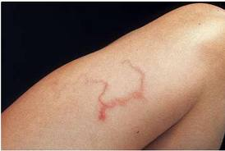
& in Baghdad incidence of 1.2% out of 95 people examined (Bialy 1956).

Treatment in animals :
- albendazole, twice daily for 3 consecutive days at 100 mg/kg;
- thiabendazole, once a day for 3 consecutive days at 50 mg/kg;
- fenbendazole, once a day for 3 days at 50 mg/kg;
- ivermectin, one dose at 200 μg/kg .

